Ideation Phase

Brainstorm & Idea Prioritization Template

|  |  |
| --- | --- |
| Date | 27 October 2023 |
| Team ID | MN2023TMID06022 |
| Project Name | Electronic Voting System |
| Maximum Marks | 4 Marks |

# Brainstorm & Idea Prioritization Template:

# Step-1: Team Gathering, Collaboration and Select the Problem Statement

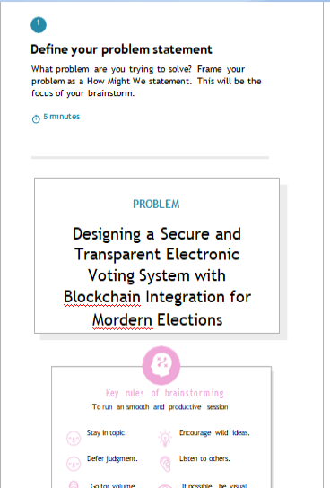

]

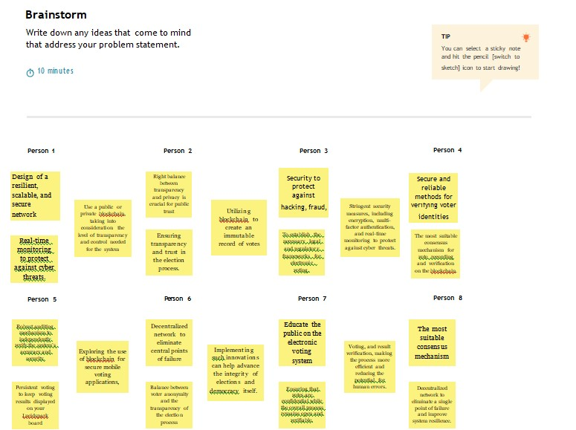

**Step-2: Brainstorm, Idea Listing and Grouping**

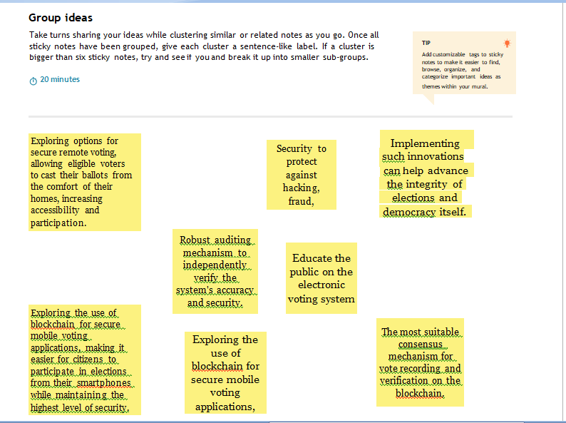

**Step-3: Idea Prioritization**

